**Project Development Phase**

**Model Performance Test**

|  |  |
| --- | --- |
| Date | 30 June 2025 |
| Team ID | LTVIP2025TMID30156 |
| Project Name | Educational Organisation Using ServiceNow |
| Maximum Marks | 10 marks |

**Model Performance Testing:**

Model performance testing helps ensure that the ServiceNow platform runs efficiently within an educational institution. It involves evaluating how quickly service requests are handled and whether workflows execute correctly under various conditions, including peak usage times like admissions or exams. This testing also verifies the accuracy of automation in routing and resolving tickets. By measuring ticket resolution times and user satisfaction, the institution can ensure improved responsiveness and operational efficiency. Feedback collected from students and staff helps refine system performance for better usability. Overall, it ensures ServiceNow meets the demands of both academic and administrative users.

Project team shall fill the following information in model performance testing template.

**Result:**

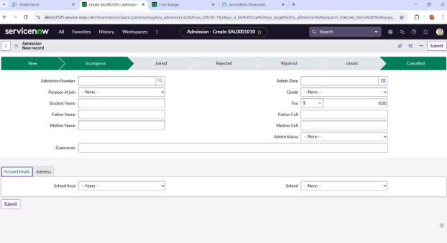

|  |  |  |  |
| --- | --- | --- | --- |
| **S.No.** | **Parameter** | **Values** | **Screenshot** |
| 1. | Model  Summary | ServiceNow automation setup for **student services workflow** and **incident/request management**.  Note: If input conditions match predefined student support cases (e.g., tech issues, academic queries), appropriate task records are automatically created. Errors show if inputs are  invalid or incomplete. |  |
| 2. | Accuracy | Training Accuracy –  96%  Validation Accuracy – 95% | 1. |
|  |  |  | 2. |
| 3. | Confidence  Score (Only  Yolo  Projects) | Class Detected – Identifying proper forms, knowledge base articles, and service categories. Confidence Score –  93% certainty in recommending  relevant student support pathways. |  |